# Online Retail Store Transactions – Project

AI generated online retail dataset csv, a large dataset idea for practicing EDA (Exploratory Data Analysis), data cleaning, and tools like Power Query, Excel, Power Pivot, and Data Model:

**🛒 Scenario:**Large e-commerce company analyzing customer purchases. The dataset contains sales transactions over the last 2 years across multiple countries.

**✅ Columns (Variables)**

| **Column Name** | Description |
| --- | --- |
| **InvoiceID** | Unique identifier for each invoice |
| **InvoiceDate** | Date and time of the purchase |
| **CustomerID** | Unique identifier for each customer |
| **CustomerName** | Full name of the customer |
| **Country** | Customer's country |
| **ProductID** | Unique identifier for each product |
| **ProductName** | Name/description of the product |
| **Category** | Product category (e.g., Electronics, Clothing, Home, etc.) |
| **Quantity** | Number of units purchased |
| **UnitPrice** | Price per unit |
| **TotalAmount** | Calculated as Quantity * UnitPrice |
| **PaymentMethod** | (e.g., Credit Card, PayPal, Bank Transfer) |
| **ReturnStatus** | Whether the item was returned ("Returned", "Not Returned") |
| **ReviewScore** | Customer review score (1 to 5) or NULL if not reviewed |
| **PromoApplied** | Whether a promo code was applied ("Yes"/"No") |
| **DeliveryDays** | Number of days it took to deliver the product |
| **ShippingCost** | Shipping cost per order |

**🧹 Messiness for Cleaning Practice**

**To make it realistic:**

* Include missing values in ReviewScore, CustomerName, and DeliveryDays.
* Introduce some duplicates.
* Add inconsistent country names (e.g., "USA", "United States", "U.S.").
* Include mixed data types (e.g., some UnitPrice as text like "$19.99").
* Create a few invalid dates or typos in column headers like "CustmerID".

**📊 Data Volume**

* Generate 20,000+ rows to ensure performance testing for Power Pivot and Excel models.
* 1000+ unique CustomerIDs.
* 500+ unique ProductIDs across ~10 categories.

In Excel the dataset was observed:

* Customer ID as primary key,
* Headers are speeling correctly
* Checking data type for each column

## PostgreeSQL

1. Query tool, use SQL to create the table:

CREATE TABLE sales

(invoice_id TEXT,

invoice_date TIMESTAMP,

customer_id TEXT,

customer_name TEXT,

country TEXT,

product_id TEXT,

product_name TEXT,

category TEXT,

quantity INTEGER,

unit_price TEXT,

total NUMERIC,

payment_method TEXT,

return_status TEXT,

review_score INTEGER,

promo TEXT,

delivery_days NUMERIC,

shipping_cost NUMERIC

);

1. Import CSV file to the blank table by right click on the table sales select Import/Export Data

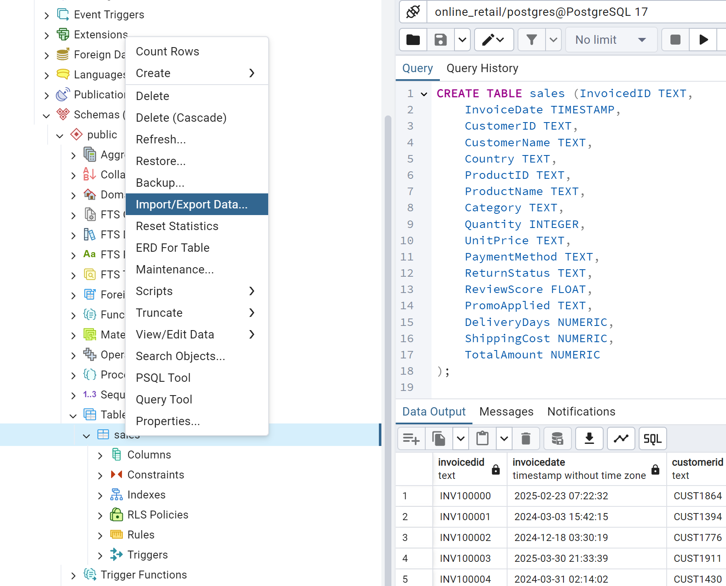

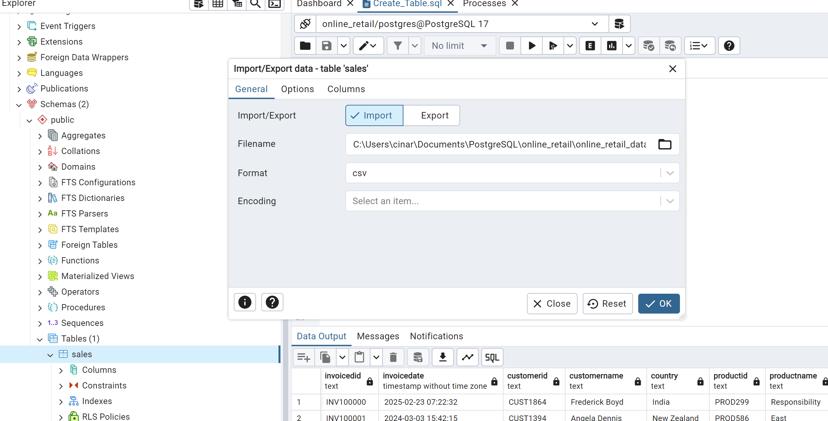

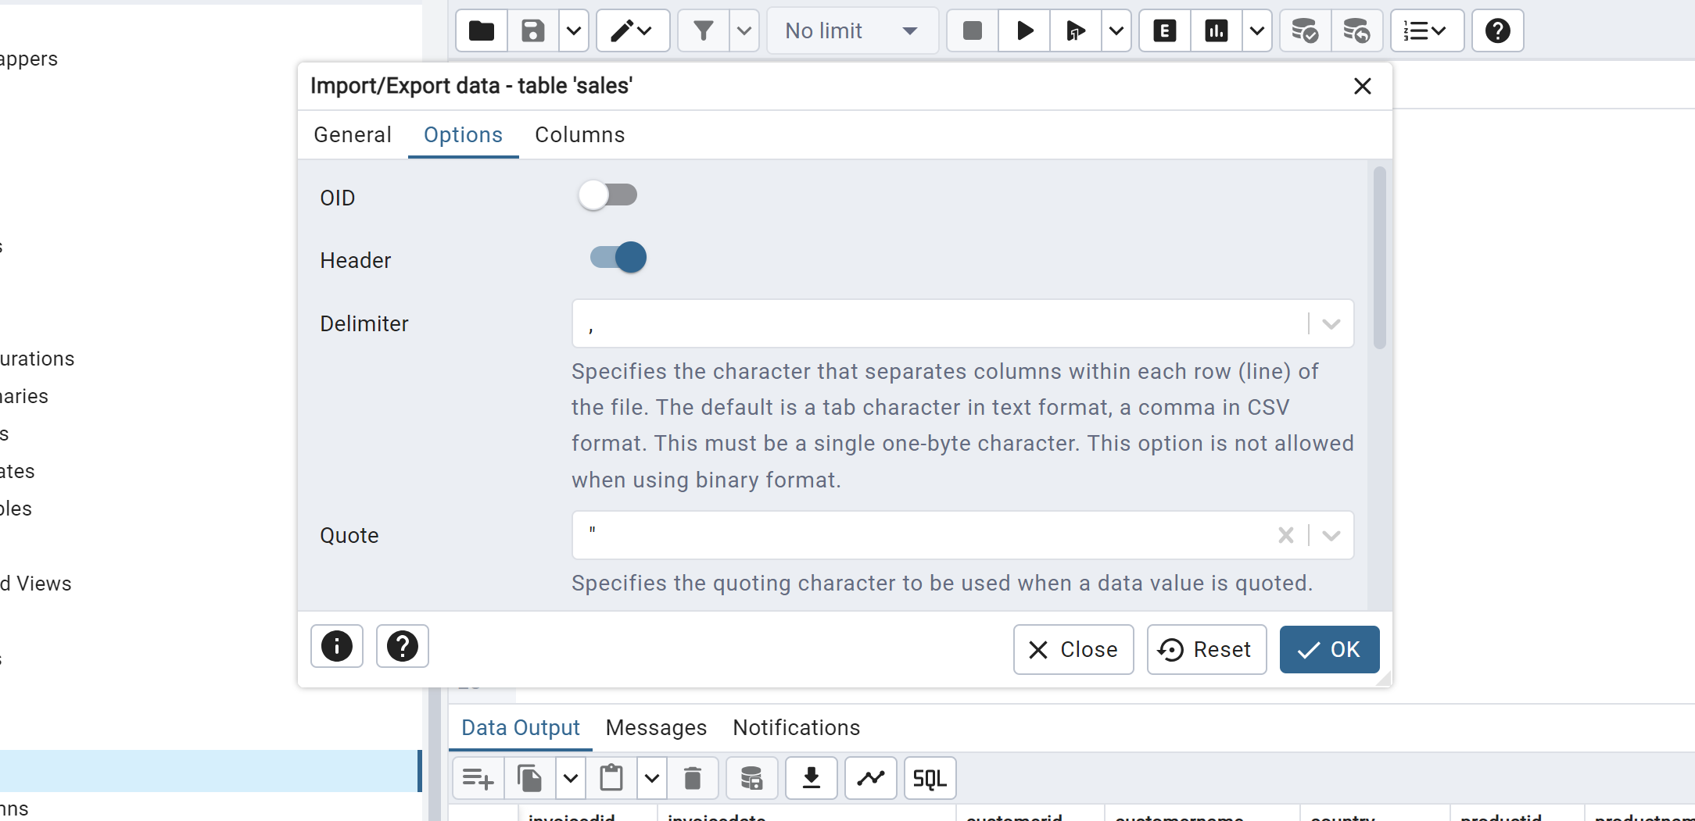

1. Checking for NULLS:

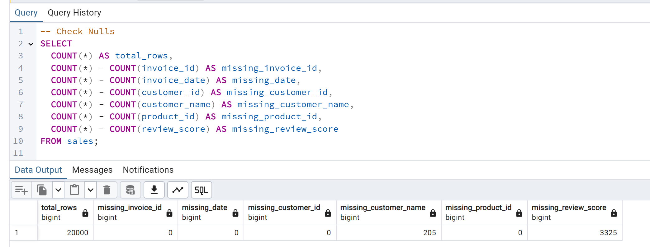

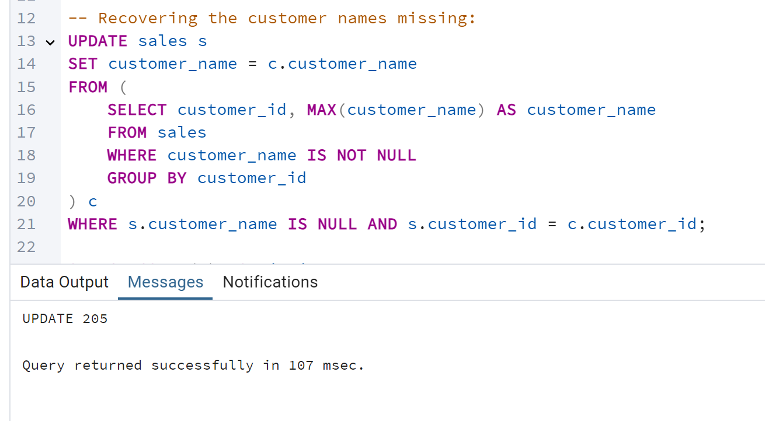

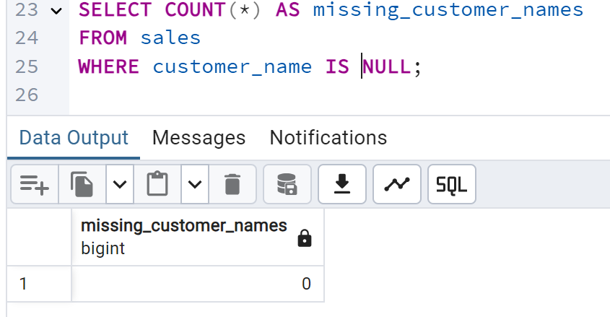

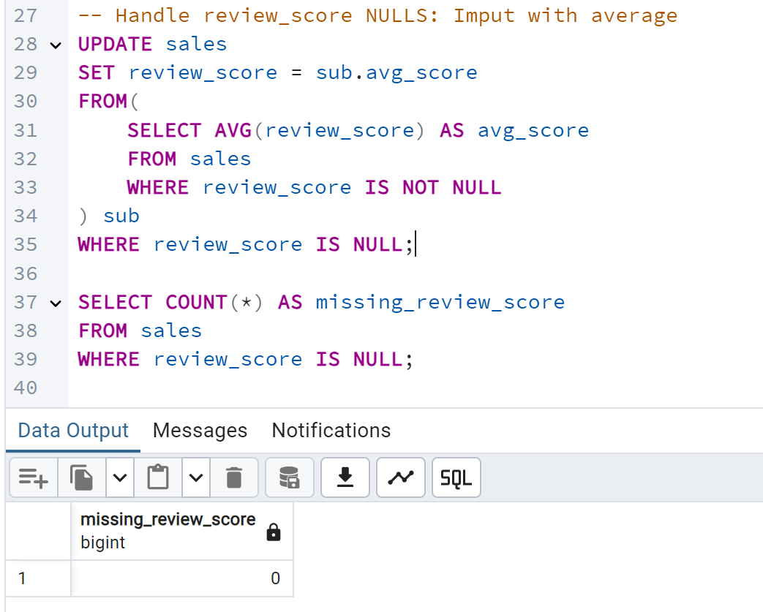

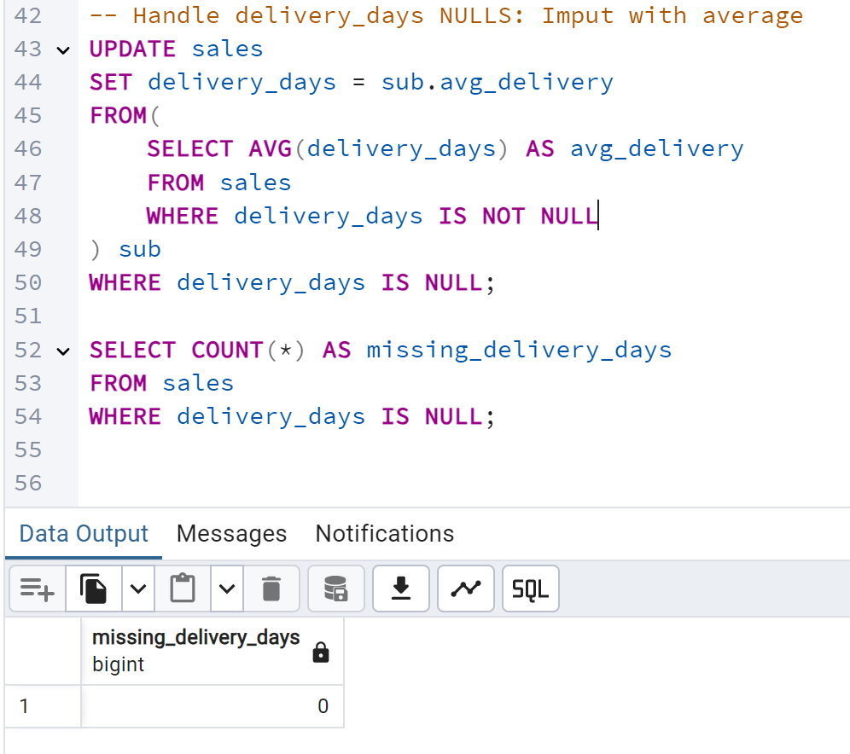

1. Checking distinct

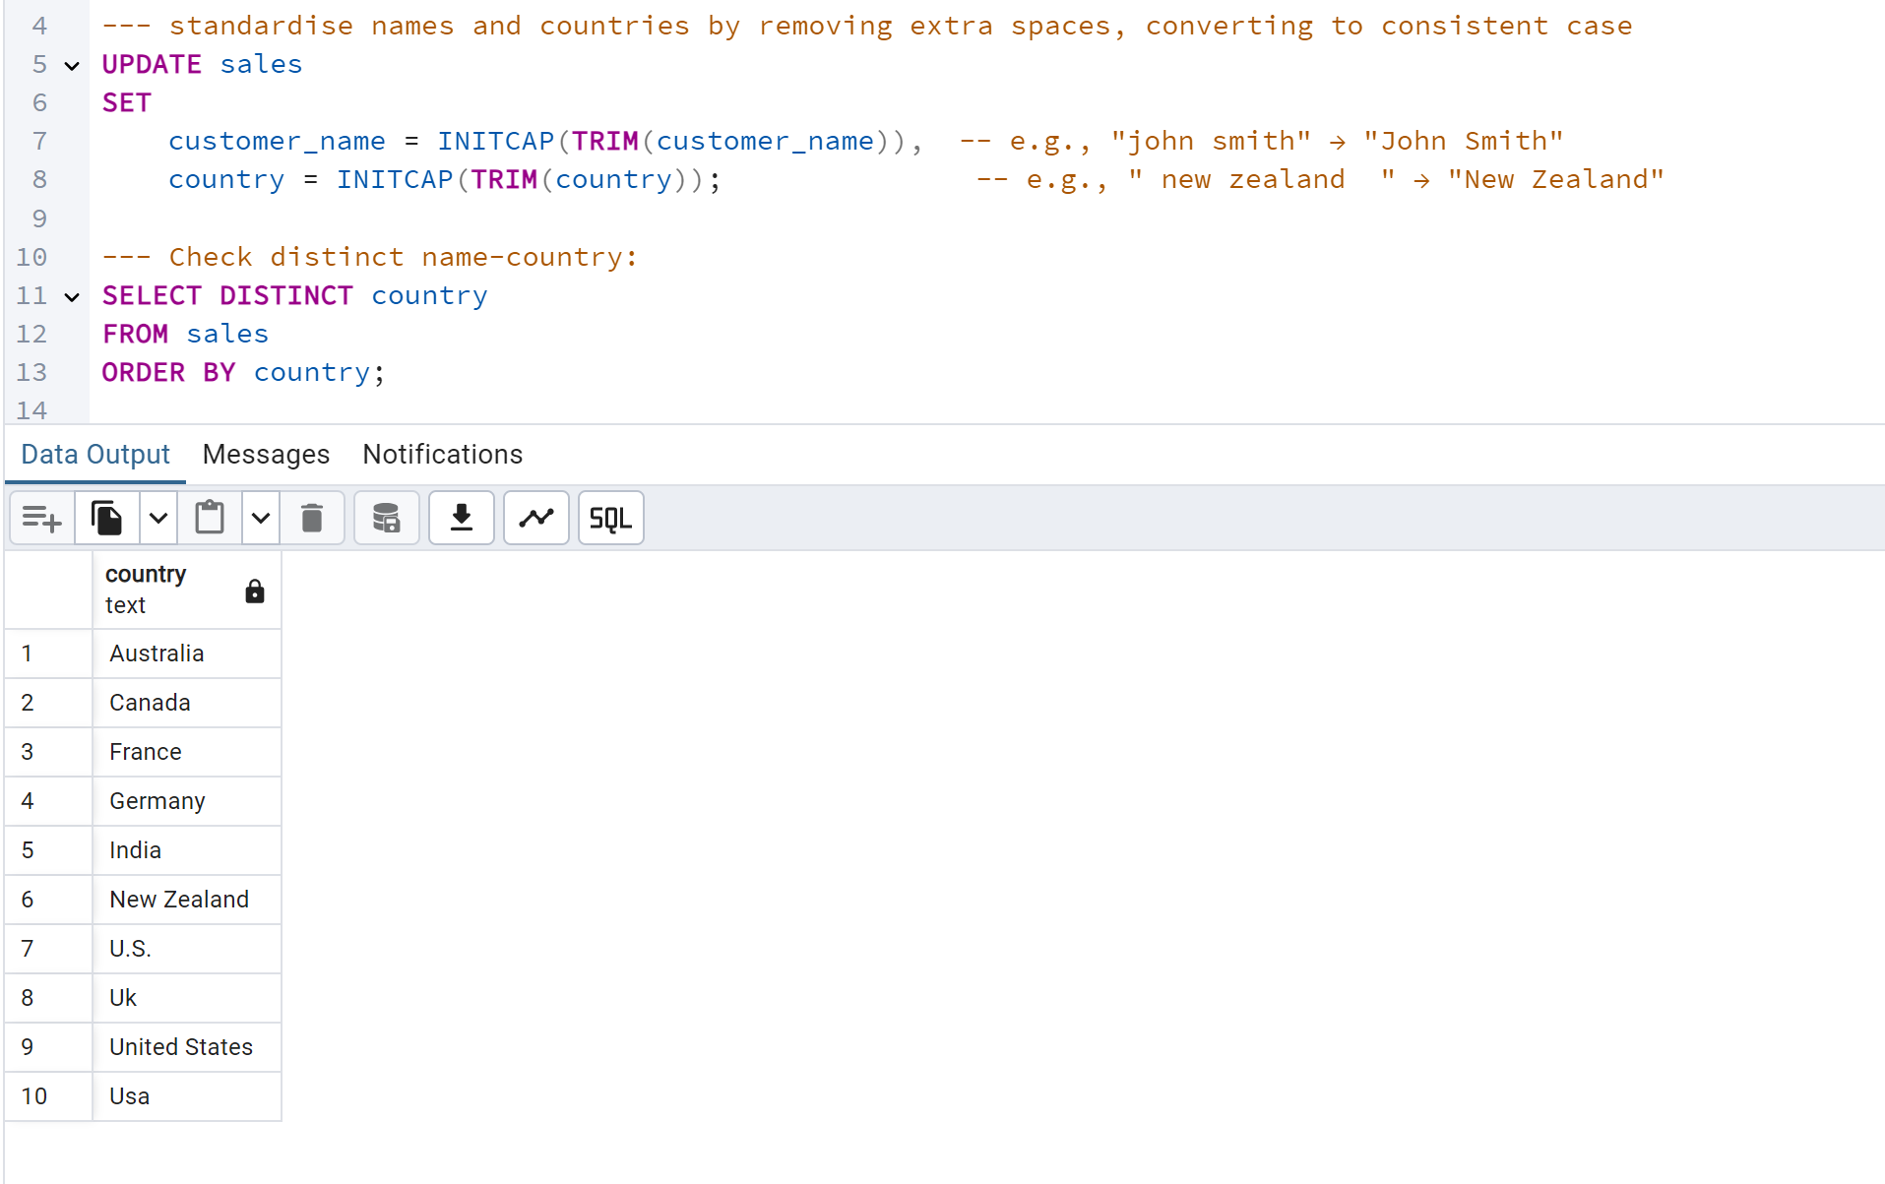

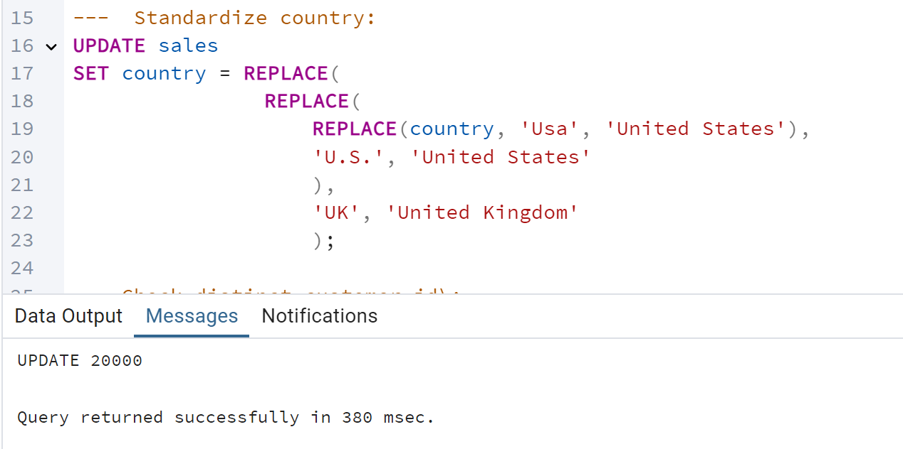

Sales table: Distinct customer_id = 1500

Distinct customer_name = 1483

Distinct invoice_id = 20000

This suggests that there are **more unique customer_ids than customer_names** in the sales table. That could be due to some customer_ids share the same customer_name, as NULL has already been removed.

1. Checking for duplicate

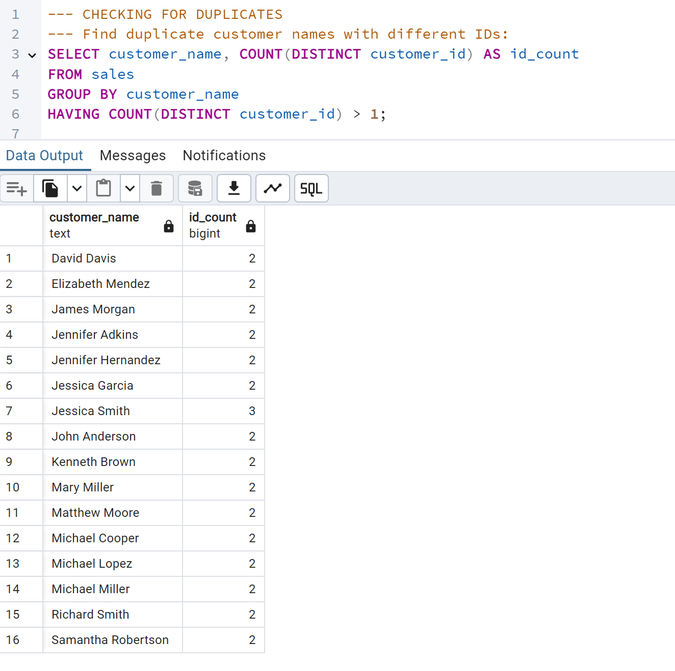

16 customer names linked to 2 different customer_ids each confirms the earlier hypothesis:

Some customers share the same name but are represented with different customer_ids.

**🔍 What This Means**

* customer_id is the unique identifier, but customer_name is not reliable for uniqueness.
* You may have:
  + Duplicate customers entered the system more than once.
  + Multiple accounts per customer name.
  + Or coincidentally shared names (less likely, but possible).

Decision: **Avoid Future Ambiguity**

If this dataset will be used for analysis or reporting:

* Use customer_id for all aggregations.
* Use customer_name **only for display**, not for uniqueness.

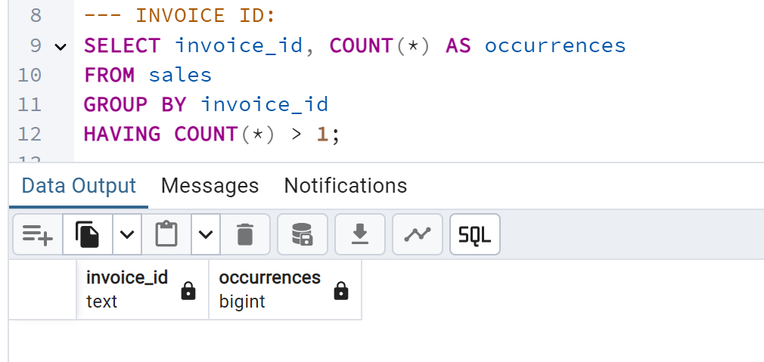

In the sales table should have a distinct entry of invoice_id, so it is confirmed that does not have duplicate.

1. Split table

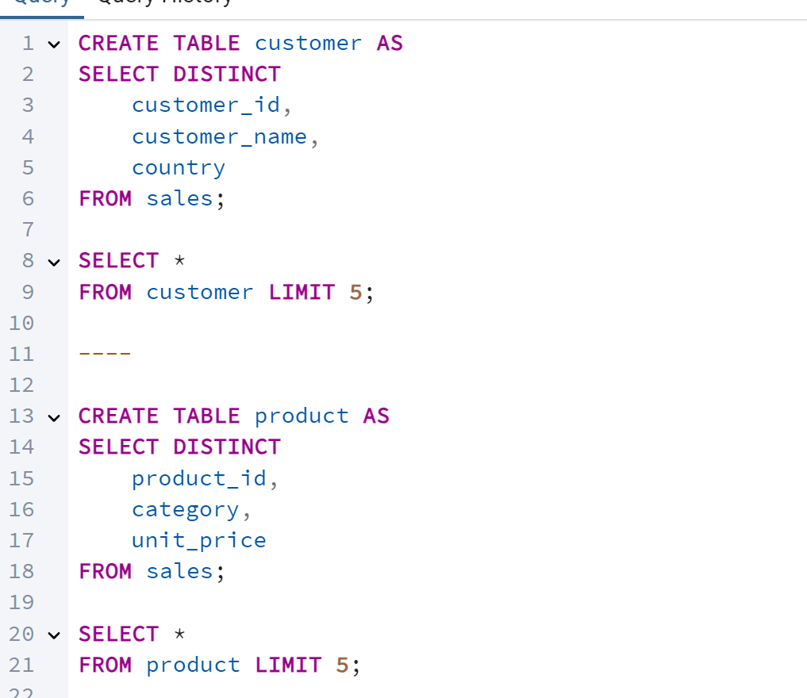

After created customer table, checking for duplicate it was noticed customer_id duplication, checking for duplicate:

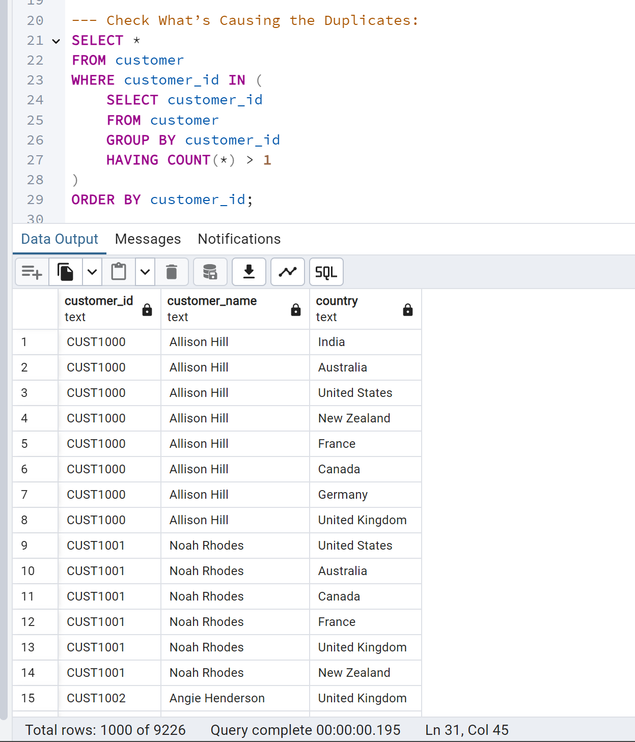

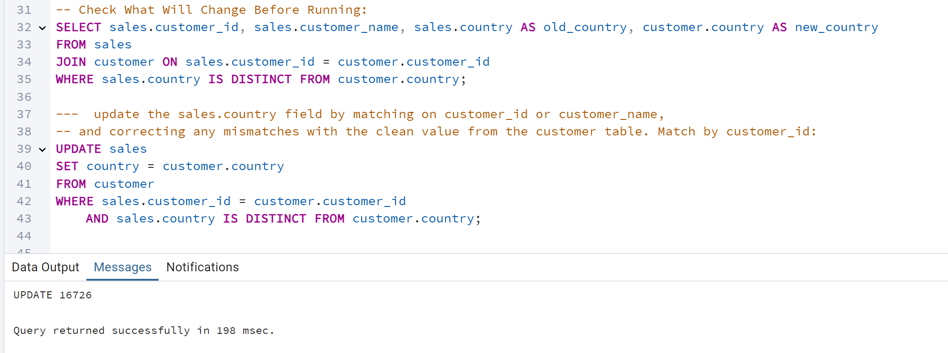

customer_name Distinct = 1483

customer_id = 1500

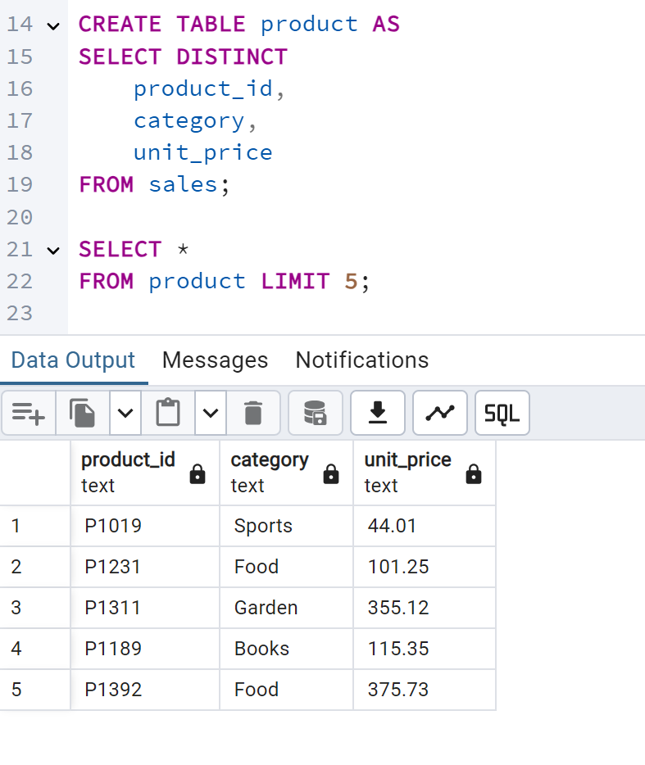

No duplicate product_id in product table.

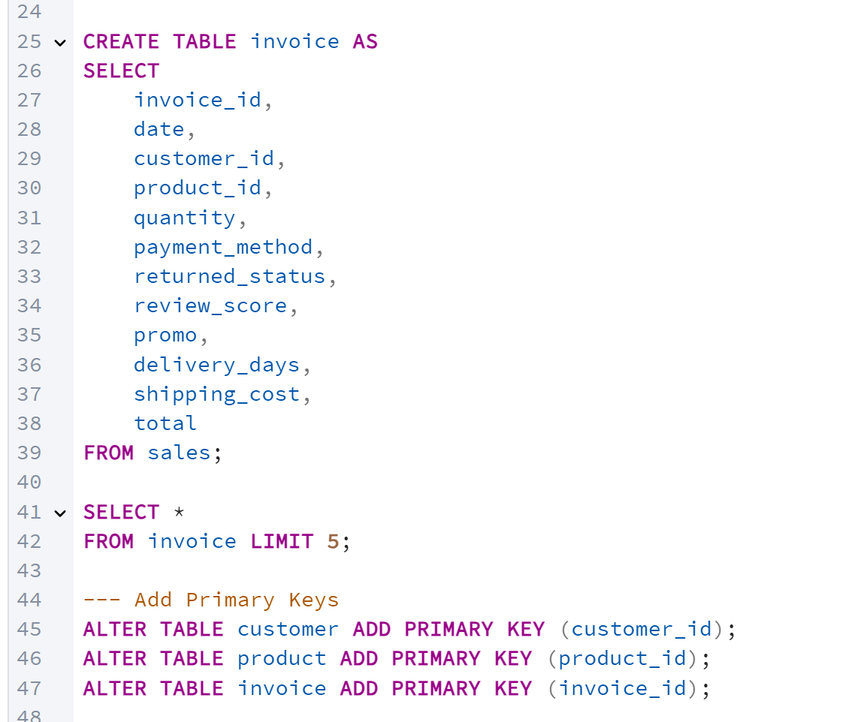

No duplicate invoice_id in invoice table.

1. Checking for duplicate

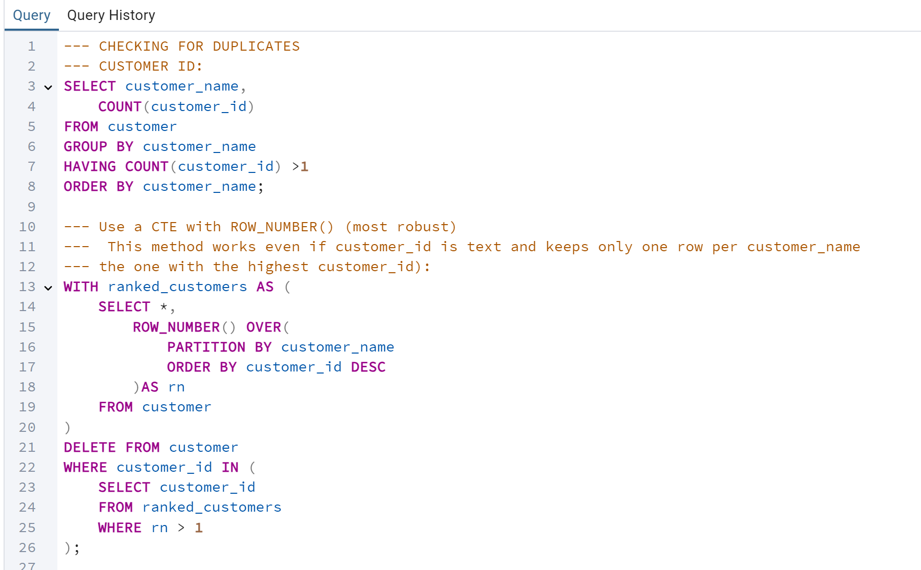

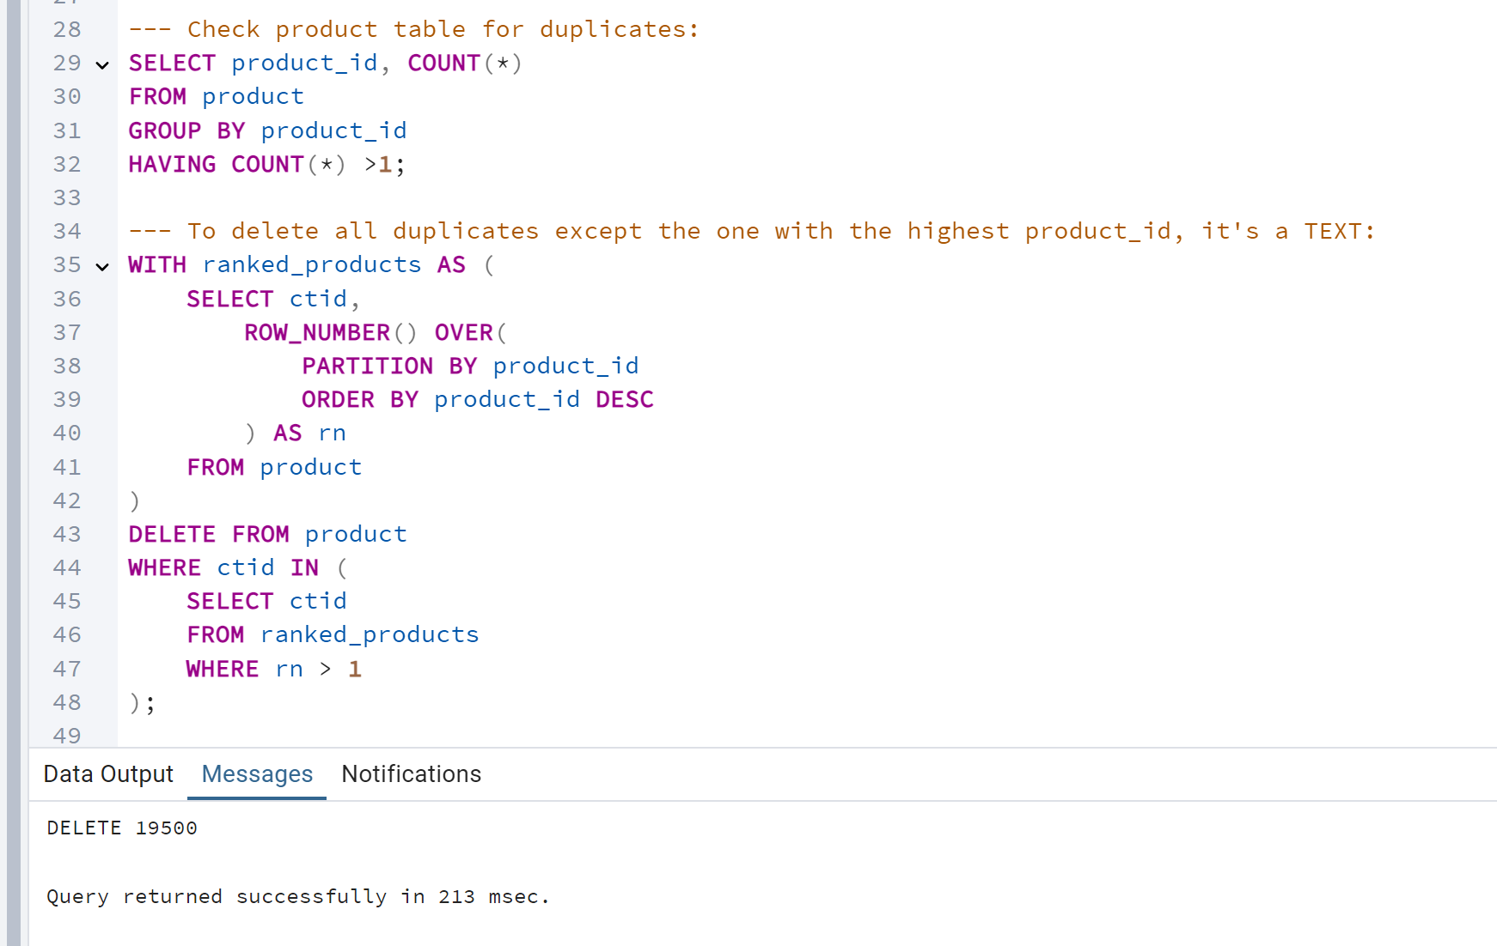

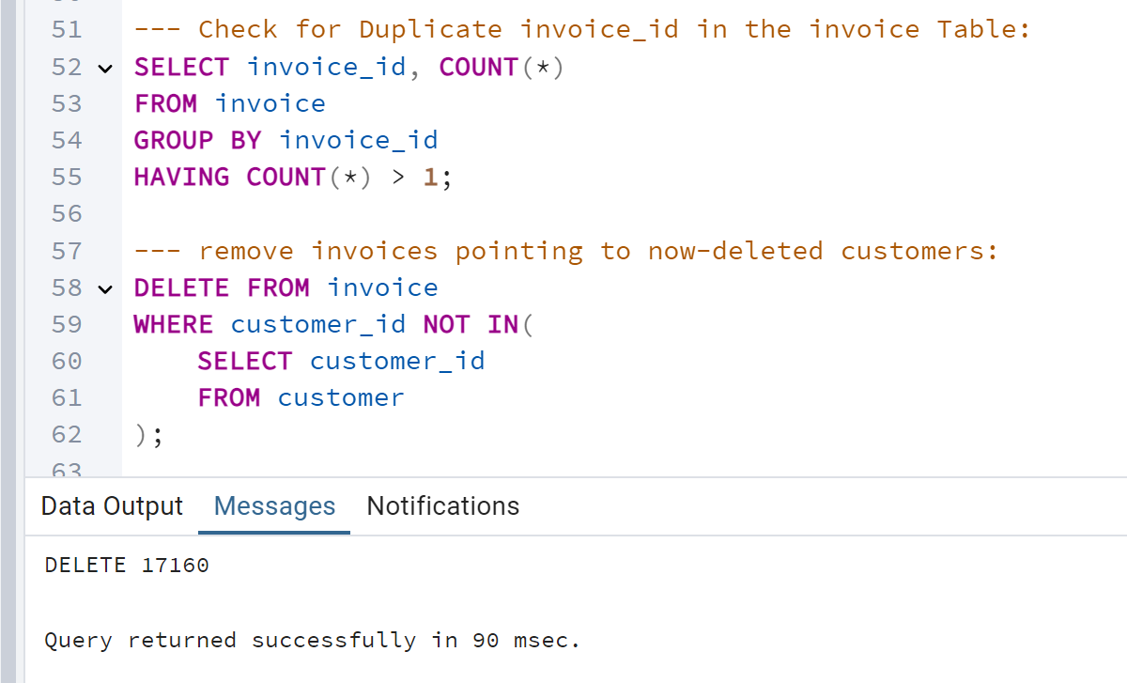

--- already deleted invalid customerids from the invoice table (those no longer existing in the customer table)

--- and you still have duplicate invoice rows, the duplicates are likely due to repeated invoicedid or entire invoice lines,

--- independent of customerid.

1. Primary Key and Foreign key

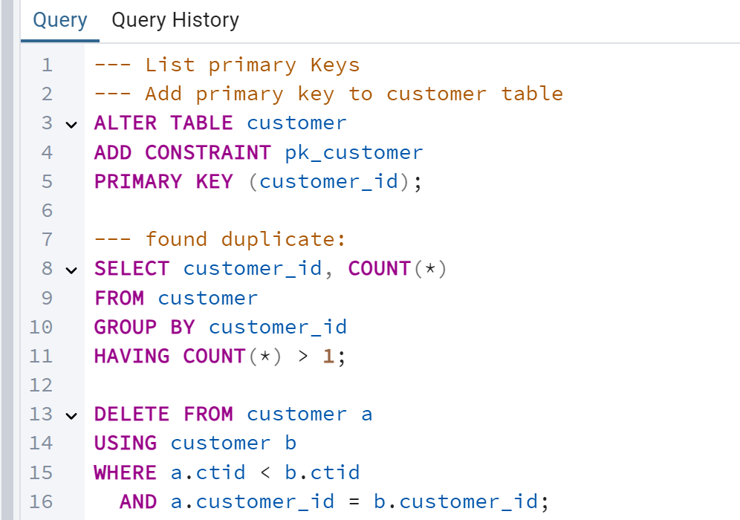

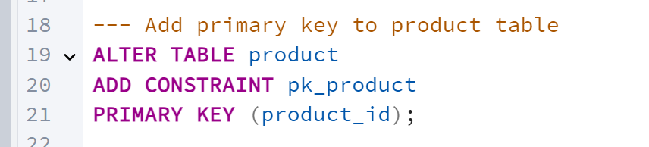

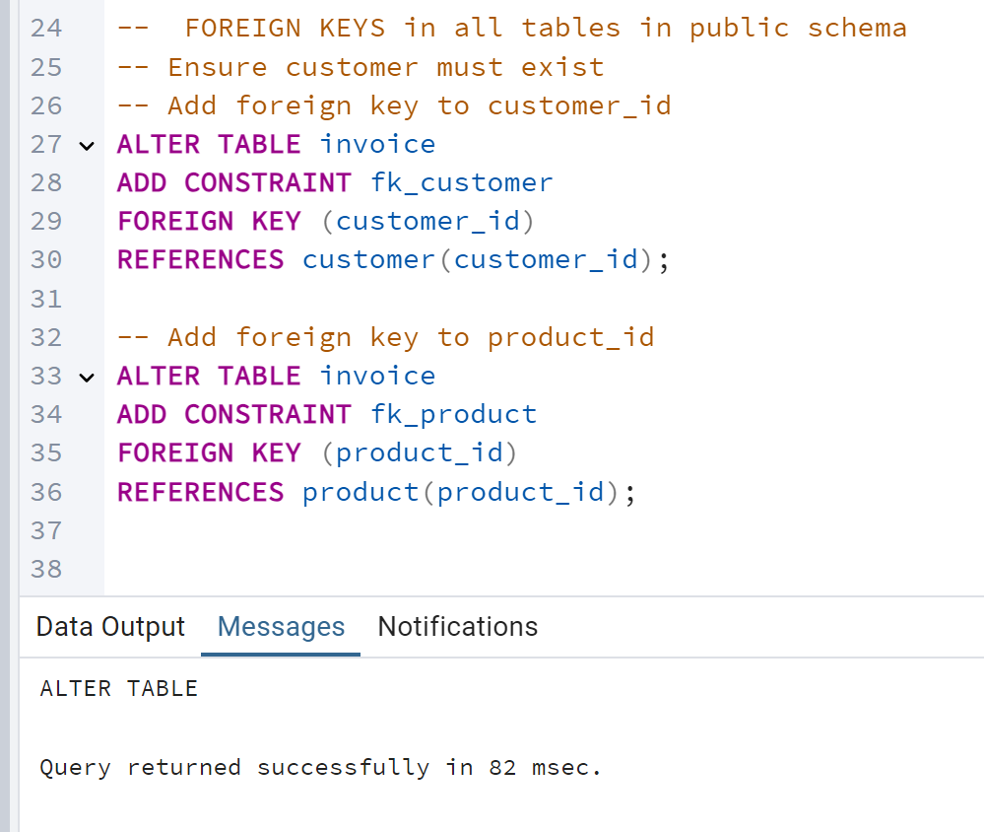

1. EDA (Exploratory Data Analysis)

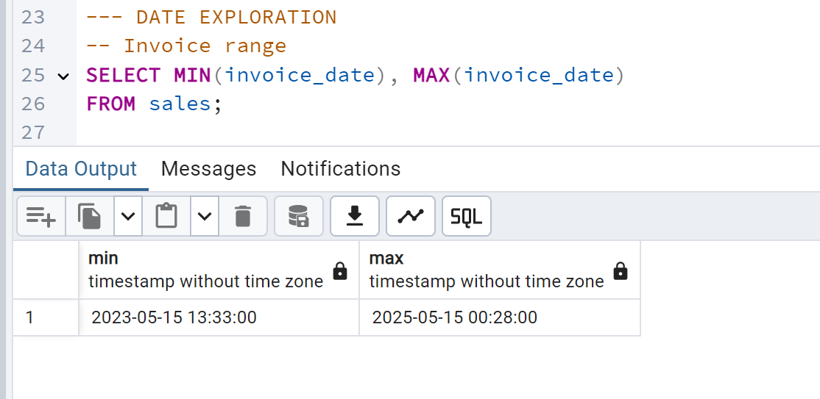

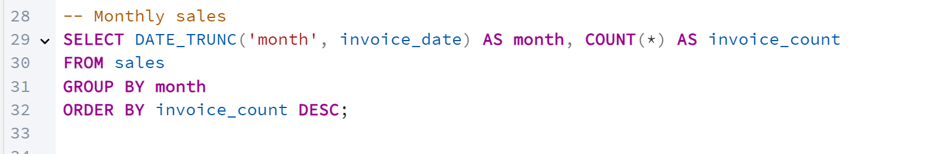

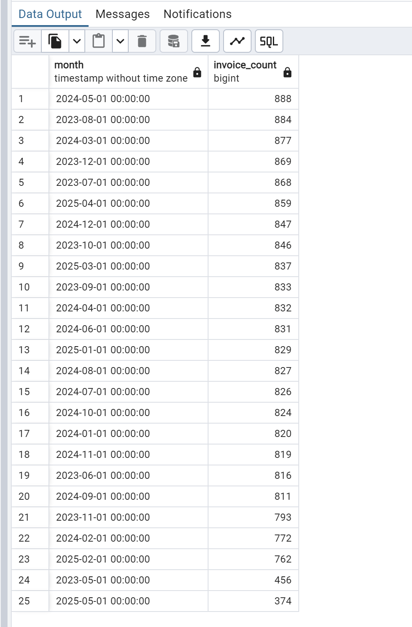

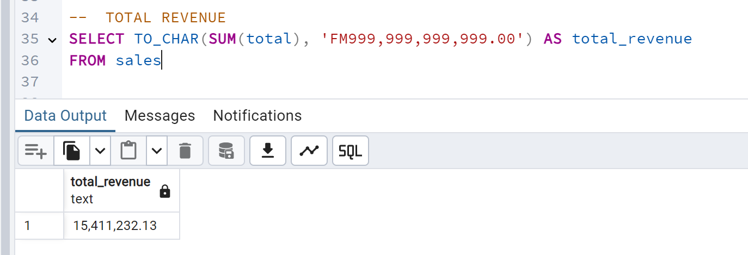

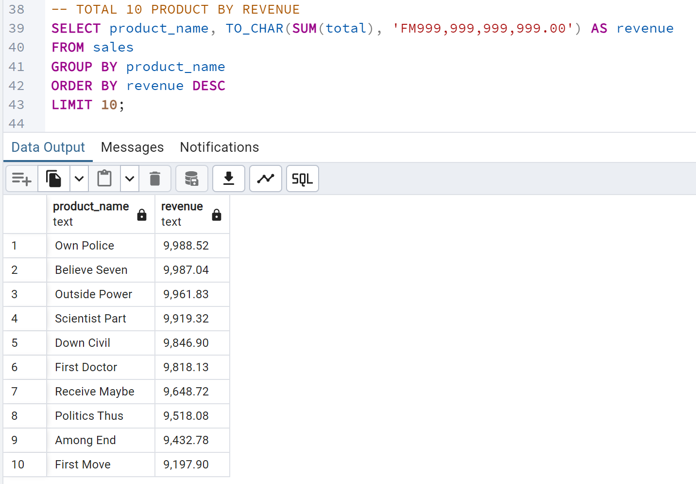

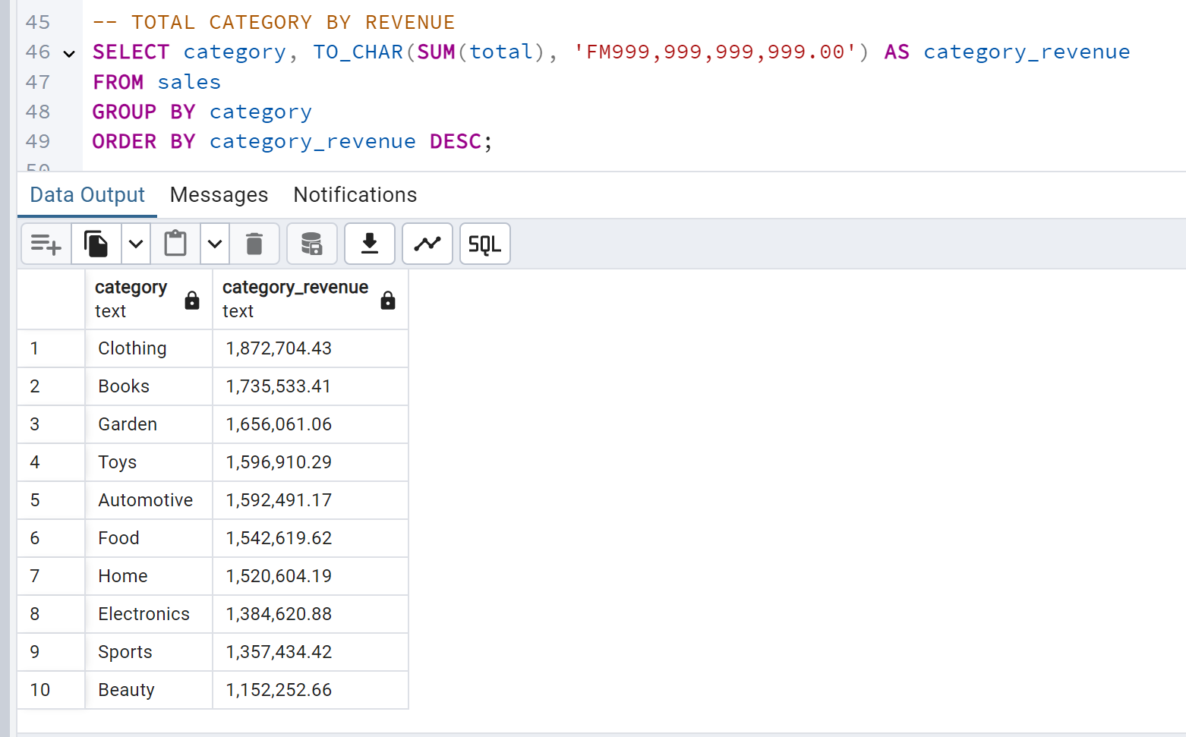

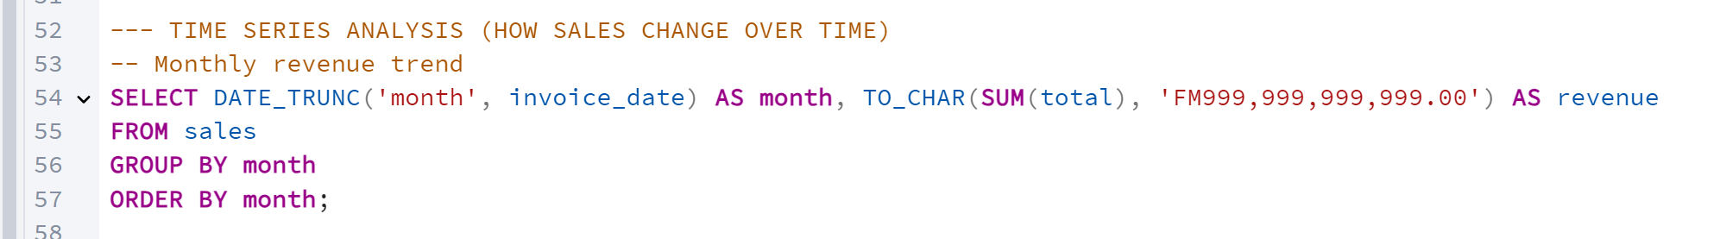

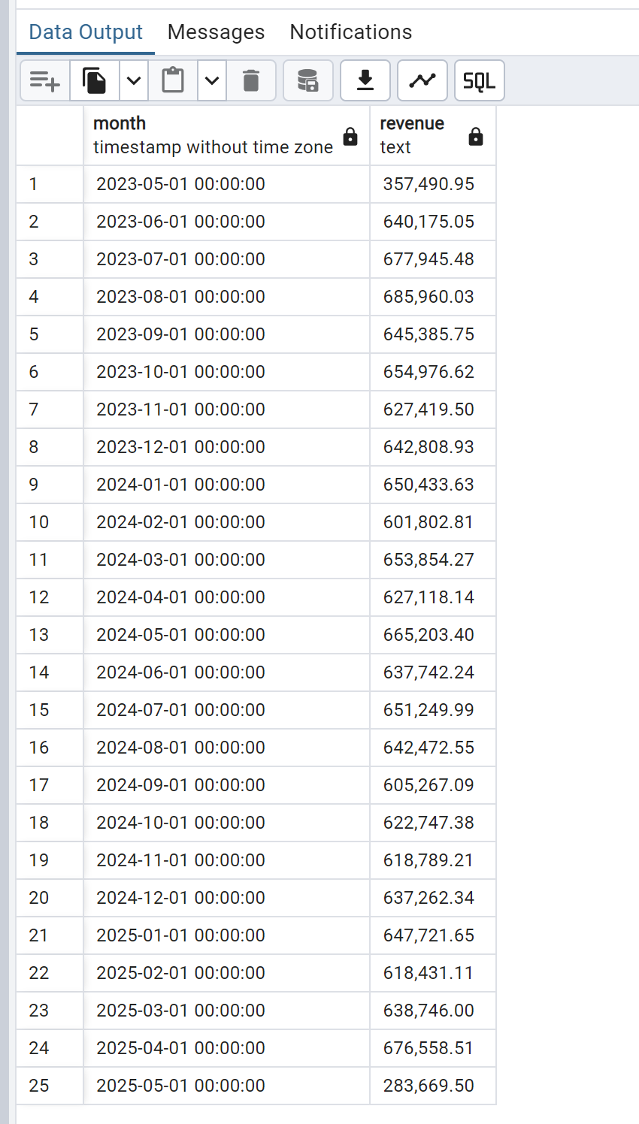

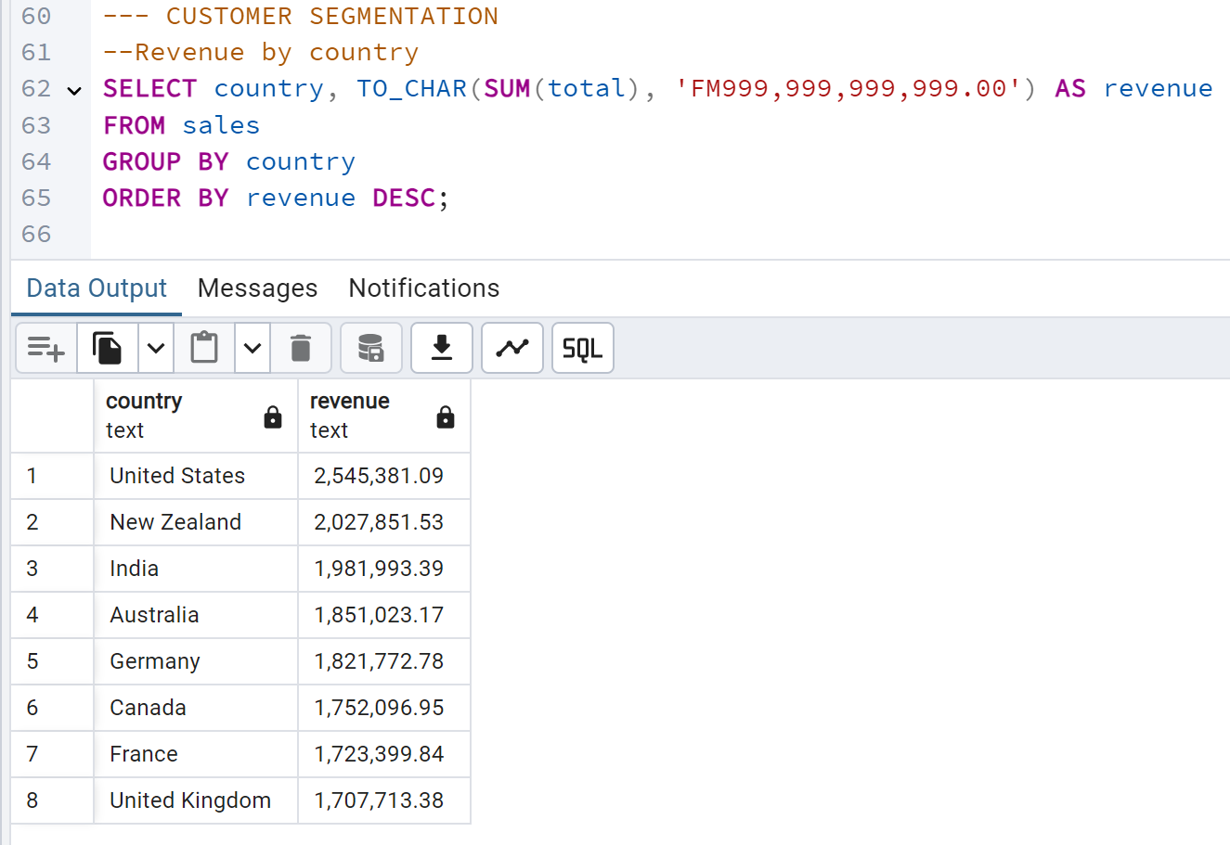

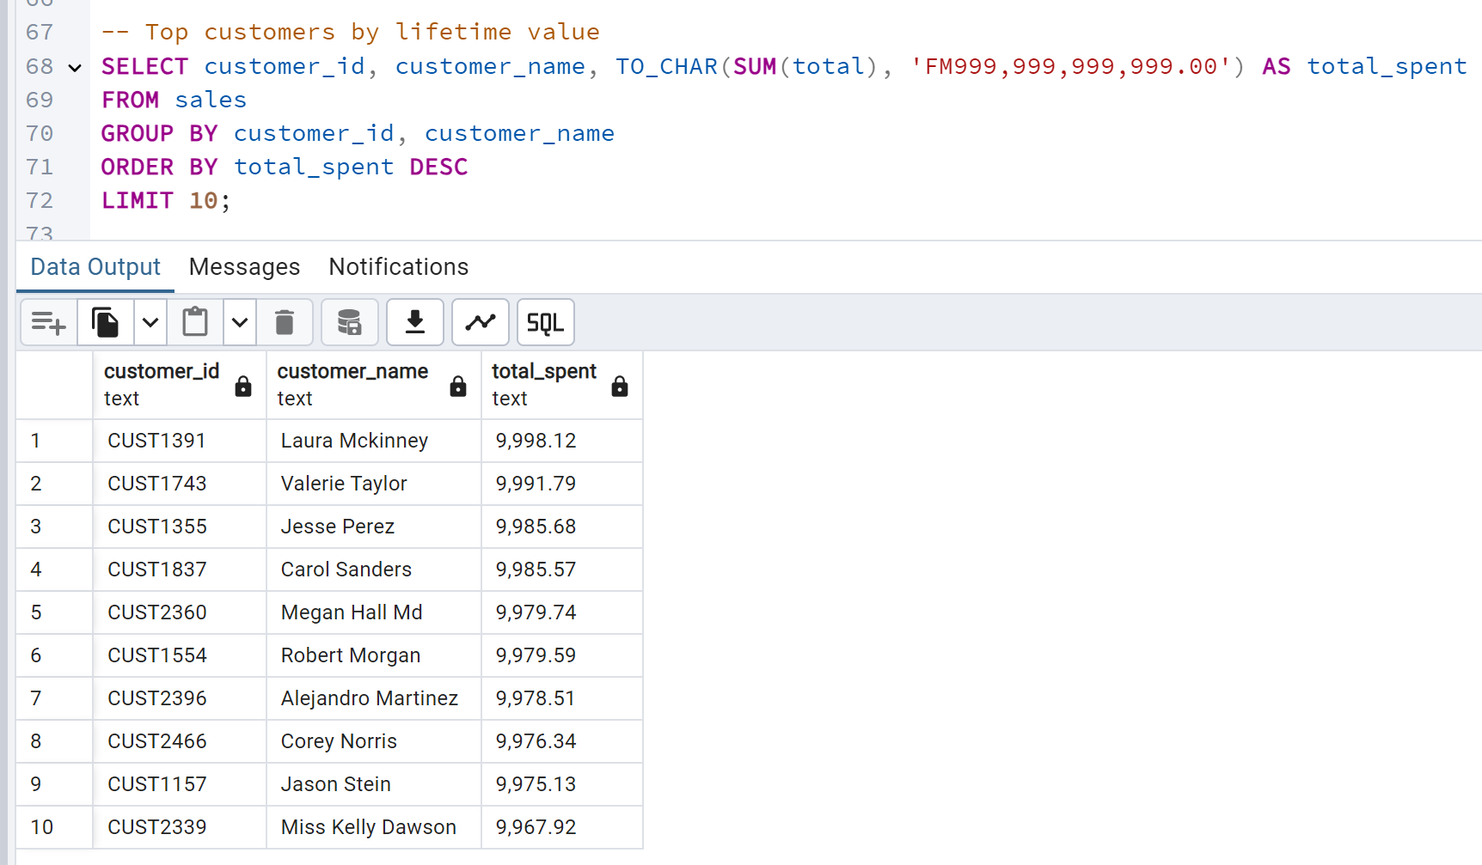

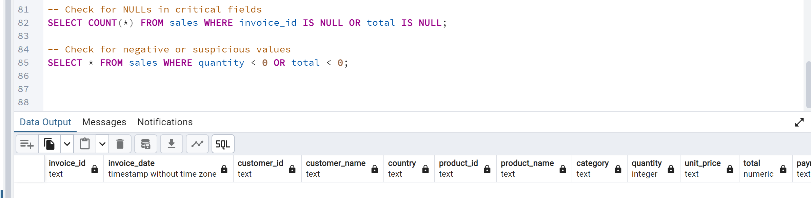

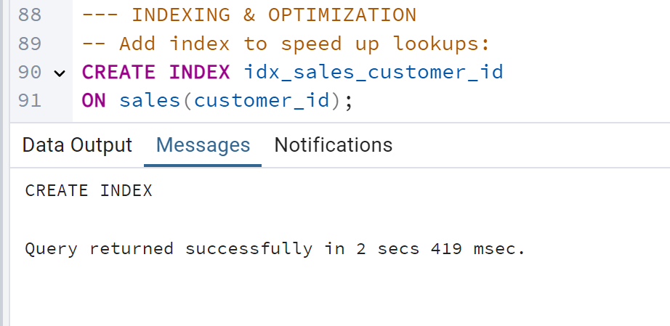

**🧠 What is an Index?**

An **index** is like a table of contents. Instead of scanning every row, PostgreSQL uses the index to jump directly to the rows it needs.

## Power BI

1. Connecting PostgreeSQL database to Power BI

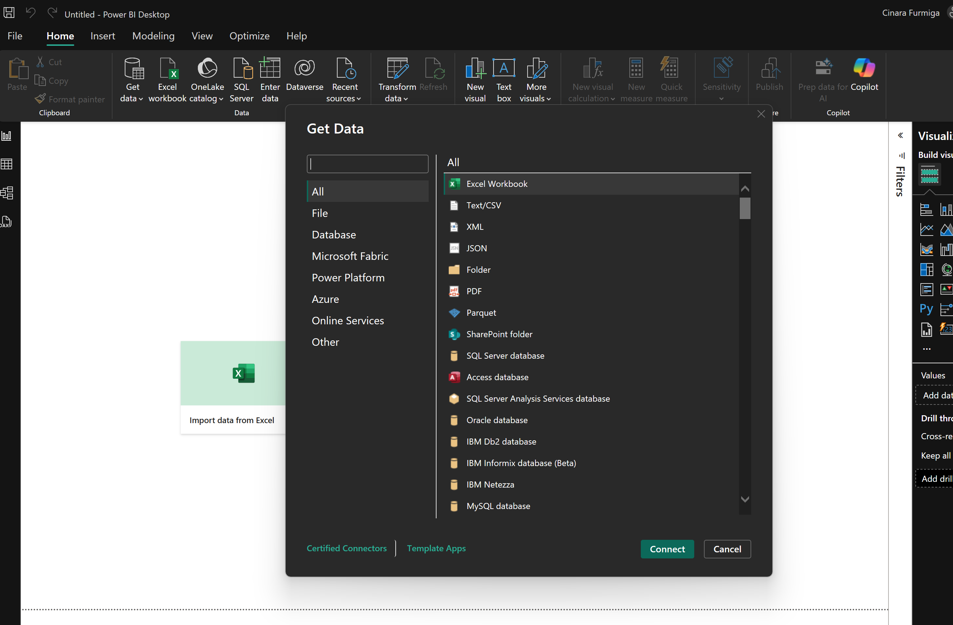

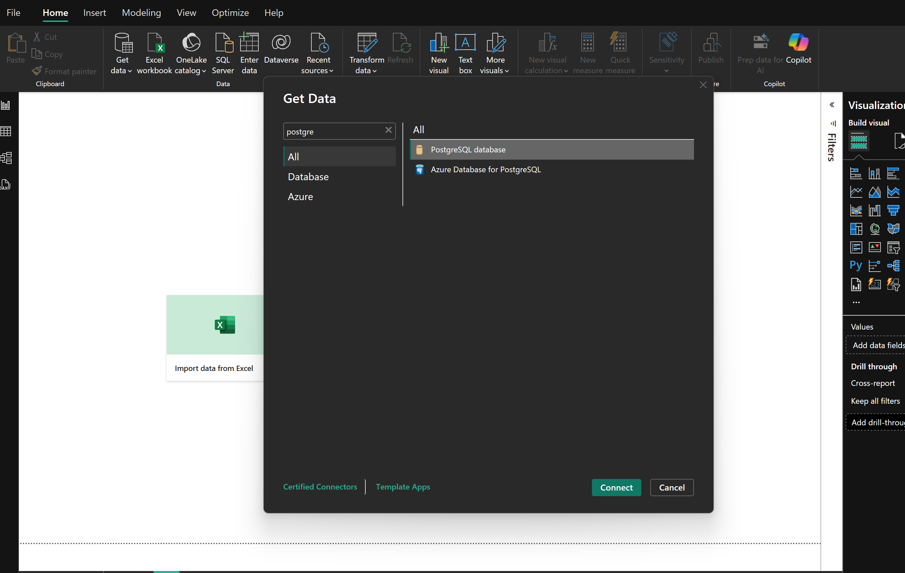

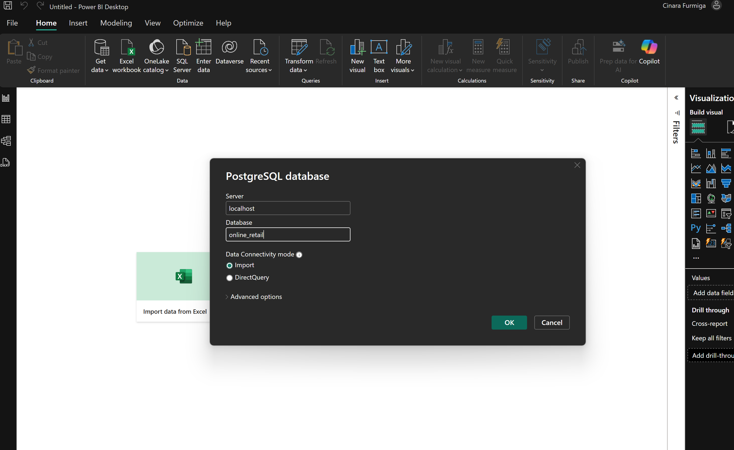

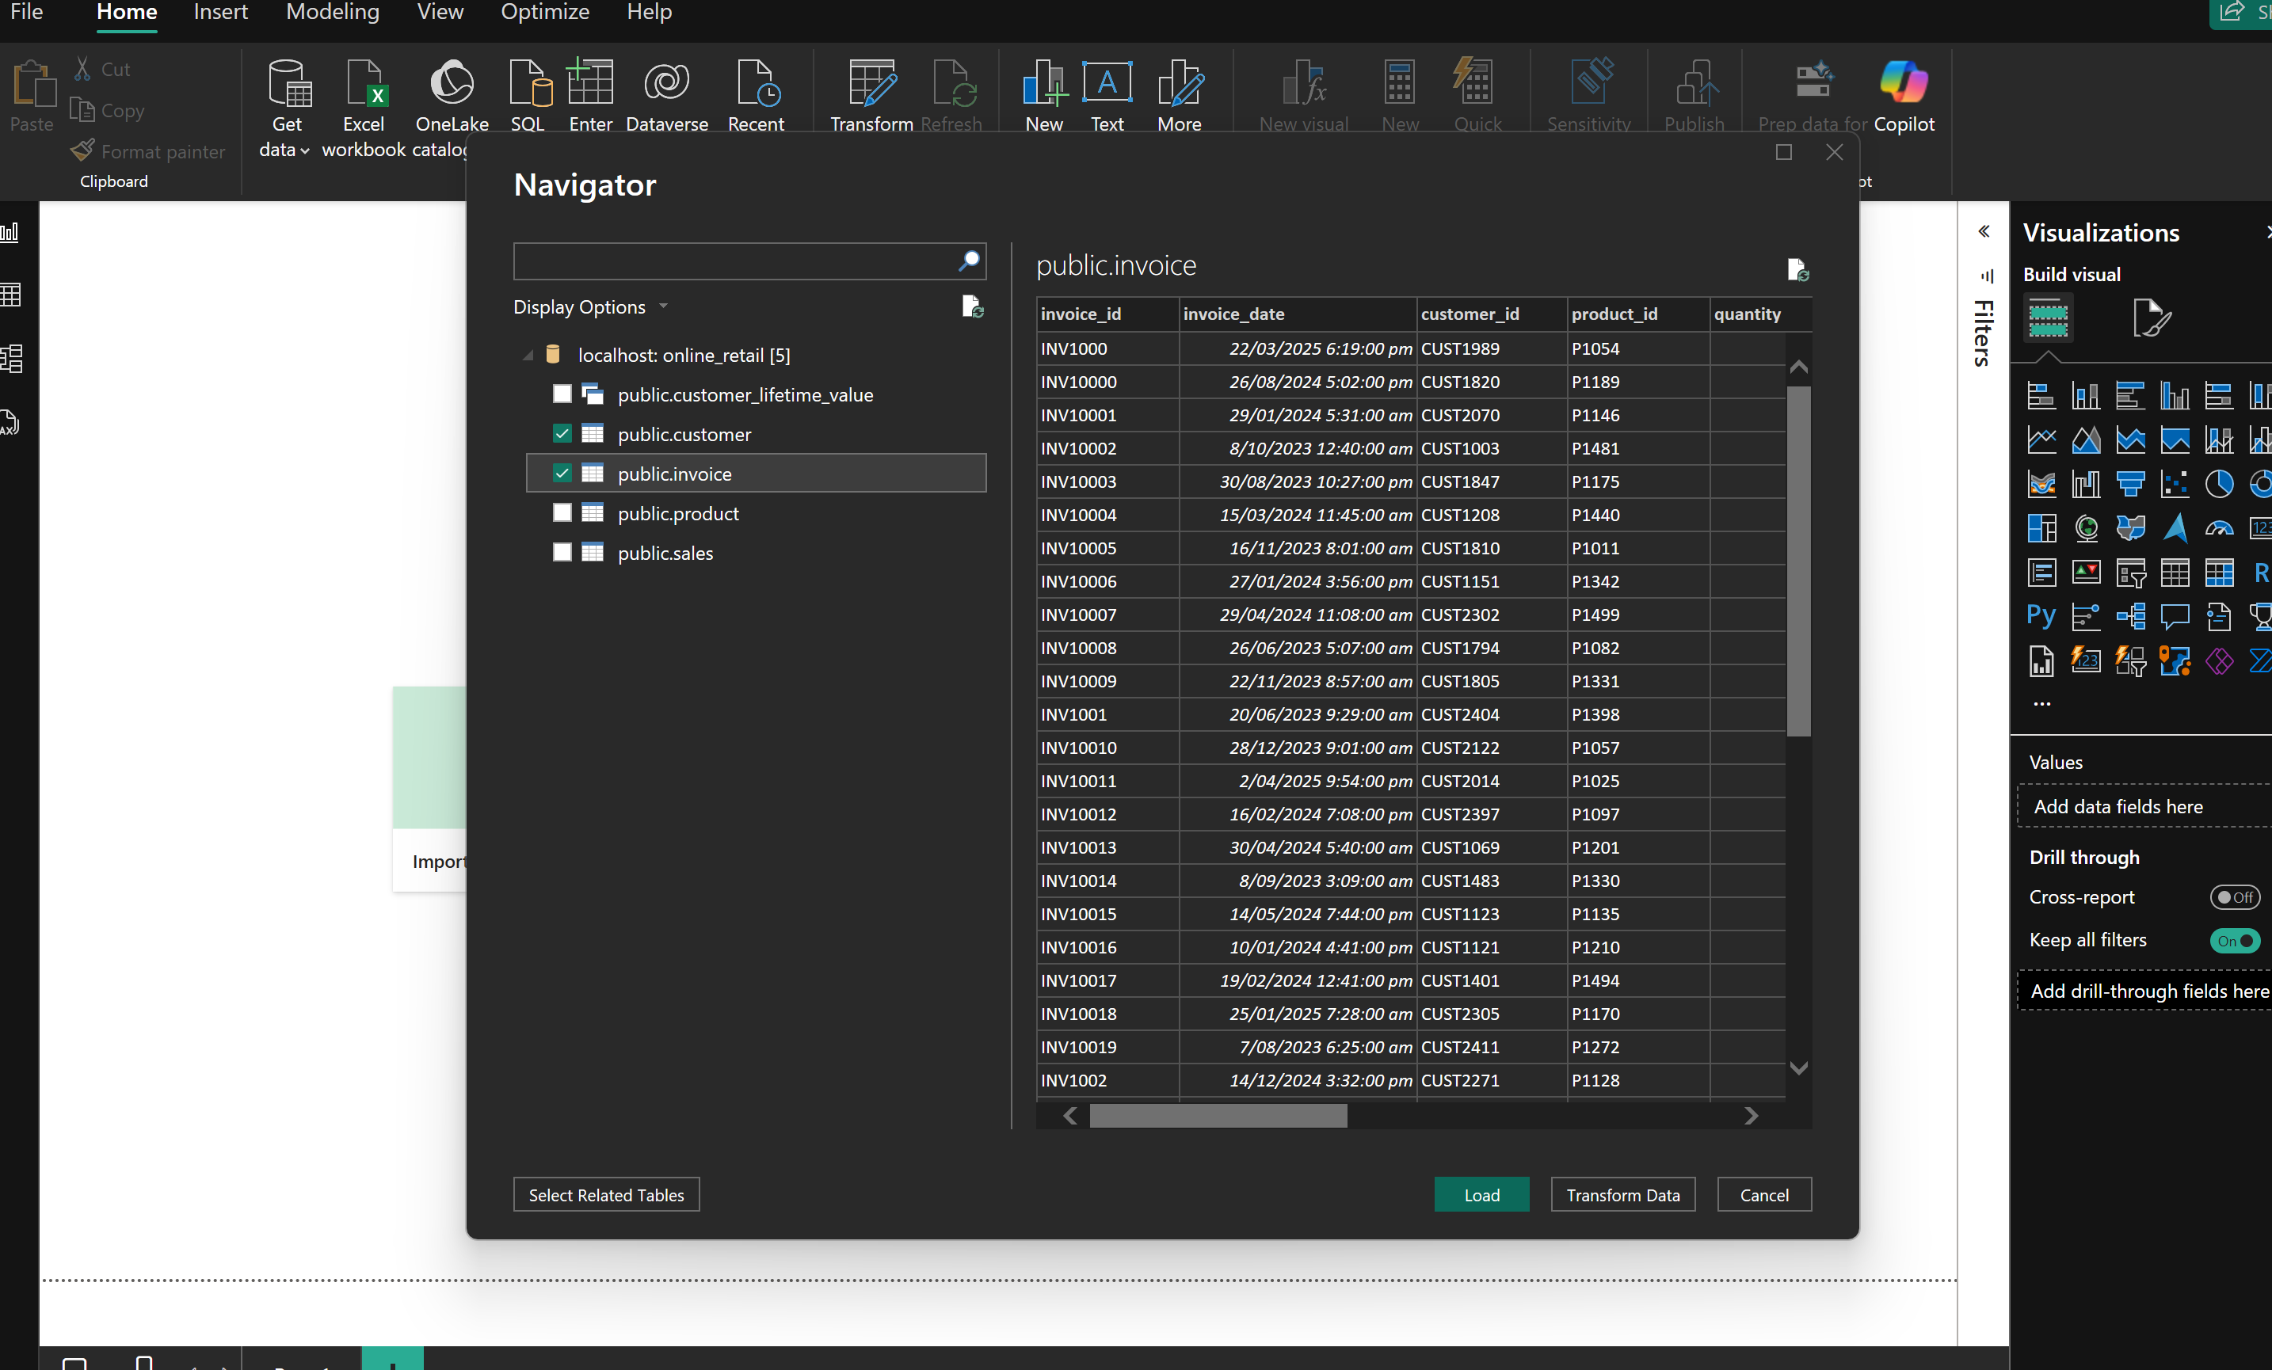

POWER QUERY:

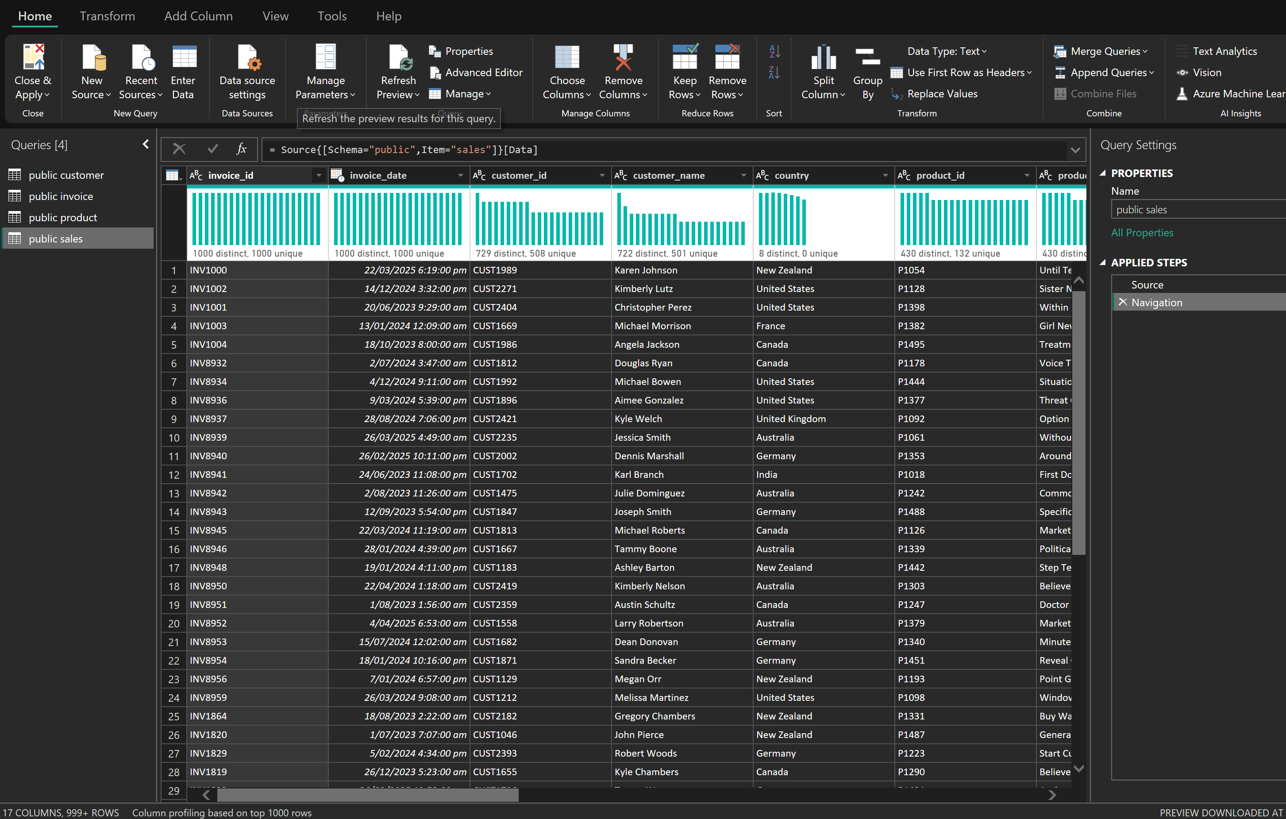

* Change data tables to customer, invoice, product and sales

MODEL:

* Create a Date Table:

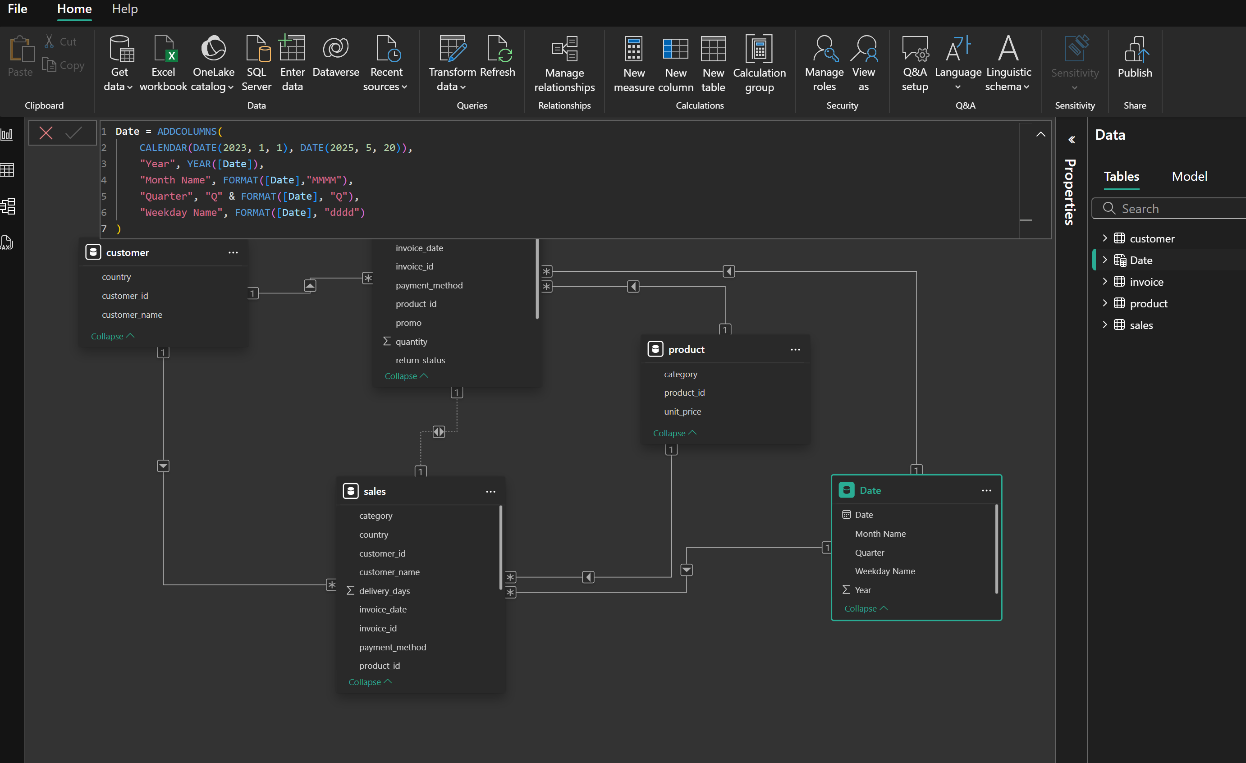

* Relationship:

Once created:

1. Drag the **Date** column from Date Table.
2. Connect it to invoice[invoice_date] and sales[invoice_date] fields.

Make sure:

* The relationship is **single-directional** (from Date Table to invoice / sales).
* The Date Table[Date] is set to be **marked as a Date Table**.
* Create time of day table:

Duplicated the invoice_date 🡪 transformed to invoice_time;

Followed created a conditional column called time of day (Morning, Afternoon, Evening and Night.)

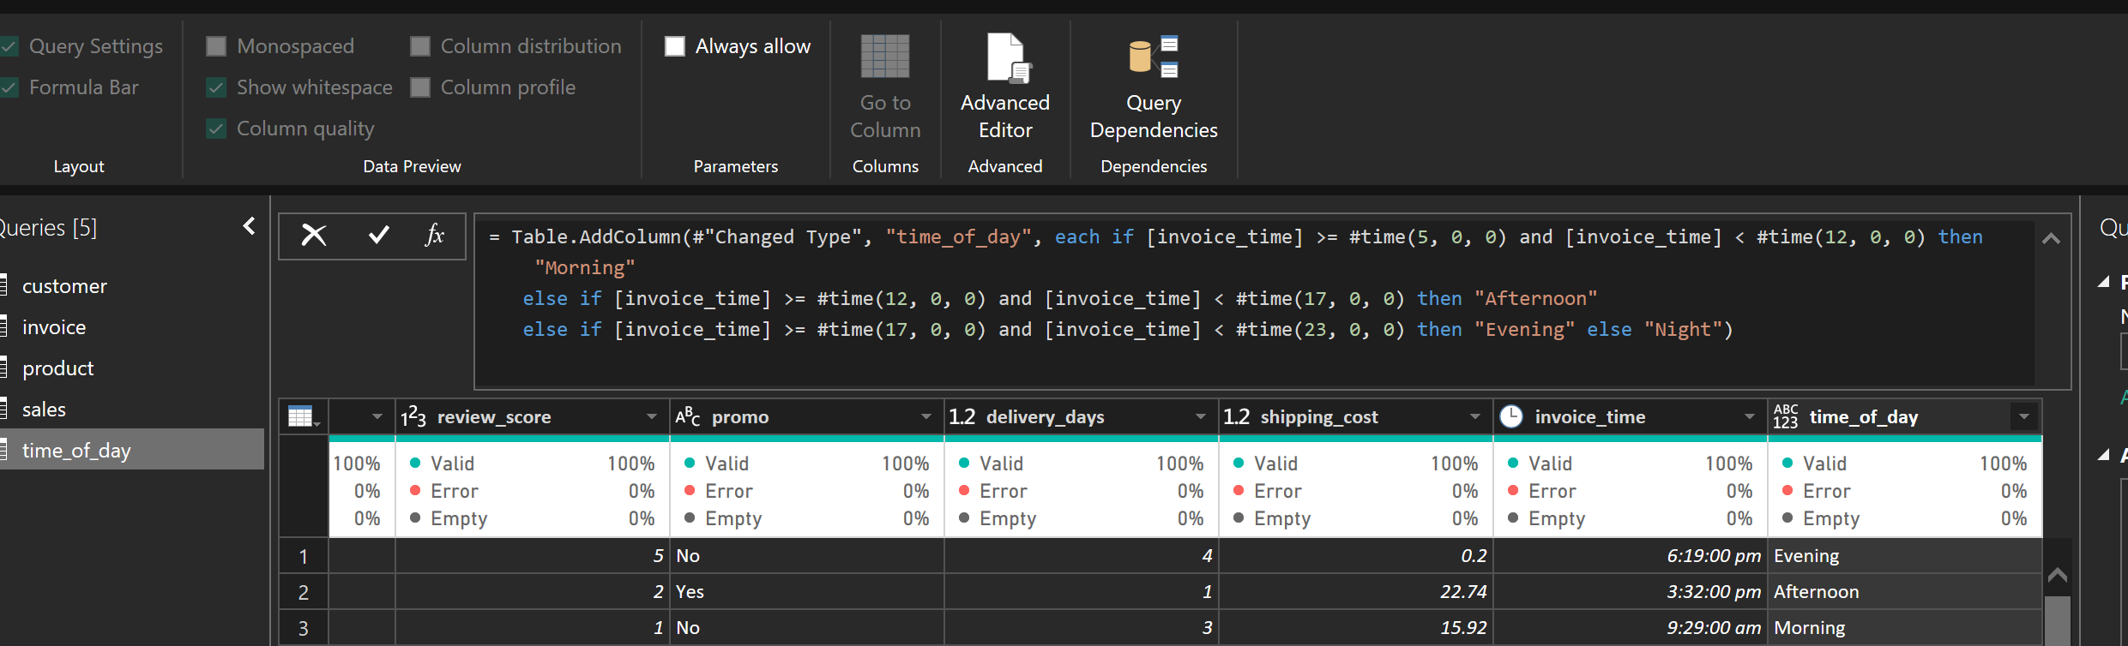

**STEP 1: Clean Your Data in Power Query**

Open Power BI → **Transform Data** → Power Query Editor.

**For the Sales (Fact Table):**

* Combine relevant data from invoice and sales tables:
  + Use **Merge Queries** to join them using invoice_id.
  + Keep only **foreign keys and numeric measures** like:
    - invoice_id, invoice_date, customer_id, product_id, quantity, unit_price, promo, payment_method, delivery_days, return_status.

🧼 Remove redundant fields like customer_name, category, etc. — these will come from dimensions.

**🗂 STEP 2: Create Dimension Tables**

**1. Customer Dimension**

* From the customer table, keep:
  + customer_id (Primary Key)
  + customer_name
  + country

**2. Product Dimension**

* From the product table, keep:
  + product_id (Primary Key)
  + category
  + unit_price

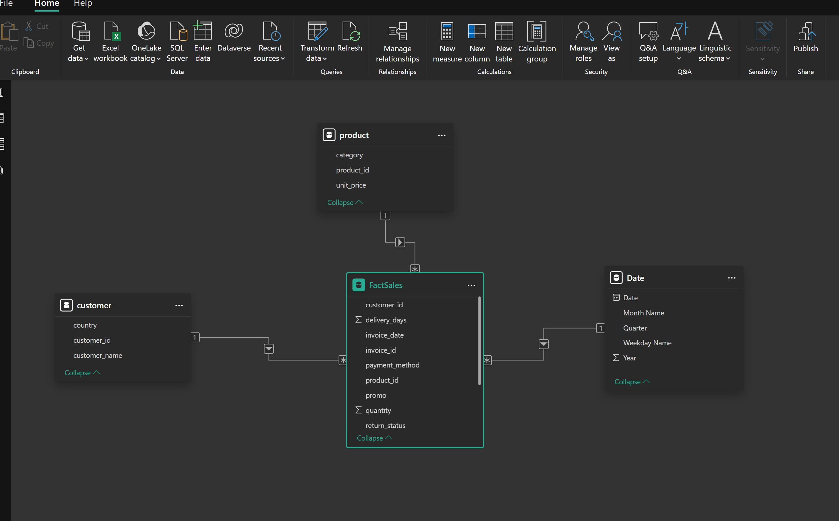

**Remove or Disable the invoice Table**

* If sales now contains all needed info (merged from invoice), the invoice table is **redundant**.

**Create Key Measures**

Start creating measures using DAX on FactSales, such as:

Total Quantity = SUM(FactSales[quantity])

Total Sales = SUMX(FactSales, FactSales[quantity] * RELATED(product[unit_price]))

Avg Delivery Day = AVERAGE(FactSales[delivery_days])

Return Rate = DIVIDE(

                  CALCULATE(COUNTROWS(FactSales), FactSales[return_status] = "Returned"),

                  COUNTROWS(FactSales)

)